|  |
| --- |
| Flux of Souls |
| COMP231 – Computer Programmer project |
| Group Members: Rudy Caliph, Randy Peacock, Stephen Dos Santos, Craig Rose, Tobias Perez and Richard Andrews. |

11/6/2013

Contents

Project introduction 2

Project Links 2

Stakeholder Registry 2

Project Summary 3

Project Description 3

High Concept Documentation 4

High Concept 4

Features 4

Player Motivation 4

Genre 4

Target Customer 4

Competition 4

Unique Selling Points 4

Target Hardware 4

Design Goals 5

Project Diagrams and Images 6

Use Case 6

Class Diagram 7

Turn Component Story Class 8

View Highscores Story Class 8

# Project introduction

The project flux of souls is a game that is undertaken by the group Caliph et al. to be completed and presented by the first week of December. This Game will be playable on the pc, developed by a group of six tracked with Pivotal Tracker and uses Github as its code repository. Below you will find links to Github and Pivotal Tracker along with the stakeholder registry.

# Project Links

Pivotal Tracker Link - <https://www.pivotaltracker.com/s/projects/908374>

Github link - <https://github.com/rpeacock/CaliphEtAl>

# Stakeholder Registry

|  |  |  |
| --- | --- | --- |
| Role | Name | Email |
| Scrum Master and Project Owner | Rudy Caliph | rcaliph@my.centennialcollege.ca |
| Developer | Stephen Dos Santos | stephendos@hotmail.com |
| Developer | Craig Rose | craig21rose@gmail.com |
| Developer | Randy Peacock | rpeacock416@gmail.com |
| Developer | Richard Andrews | Randrews1991@hotmail.com |
| Developer | Tobias Perez | tobiaspdavidson@hotmail.com |
| Project Owner | Jake Nesovic | jnesovic@my.centennialcollege.ca |
| Project Owner | Dr. Hao Lac | haolac.at.centennial@gmail.com |

# Project Summary

The project lifecycle will be 14 weeks staring from September 3, 2013 to the end of the first week of December. The project will included:

* Single Player Mode – This will be broken down to three difficulties for the player to choose from.
* Leaderboards – This will functions as a collection of scores from highest to lowest and will record that new scores.
* PC release -This will be a windows exclusive game.
* Mouse and keyboard Only – Most inputs will be made by the mouse and have some limited keyboard function.
* Developed in C# XNA Framework – XNA is a framework created by Microsoft for game development.
* A Setup executable program will be provided for installing the application.
* User manuals/system documentation – This document will contain both and can be found a page

# Project Description

Flux of Souls is a strategy turn based game for the pc. And the development group Caliph et al. will be creating this game. The game see you as a god that can manipulate the terrain of a section of this world. As make the world from terrain upgrades the souls that will come to occupy the area will grow and will be the source of you points. The main currency will be gold that can be used to upgrade terrain and can be acquired by selling souls. Try your best to create a world and get a high score.

# High Concept Documentation

**Flux of Souls**

Written by Rudy Caliph

## High Concept

Flux of Souls is turn based strategy game that gives the role of god to the user. The game is a top down view of a map that the players influence souls and fight of bad ones to grow the world and get the highest score possible at the end.

## Features

* World Creation and Manipulation.
* Soul Conversion for point scoring.
* Building system.
* Soul influence.
* Three modes in final and one in prototype.

## Player Motivation

As this world new god you must nurture the world and make it strive to get the best possible souls to get a high score.

## Genre

Turn based strategy game.

## Target Customer

Customers ages 14-30 strategy players.

## Competition

PC Indie strategy games.

## Unique Selling Points

* World Manipulation
* Map style game.
* A.I

## Target Hardware

PC Steam platform and Origin

## Design Goals

**Simple:** The game will be all mouse controlled and the simple user interface will make it easy to pick up for any experienced strategy game player.

**Deep:** With the good and bad A.I will make it different each time for the player and make repeat play fresh.

# Project Diagrams and Images

## Use Case

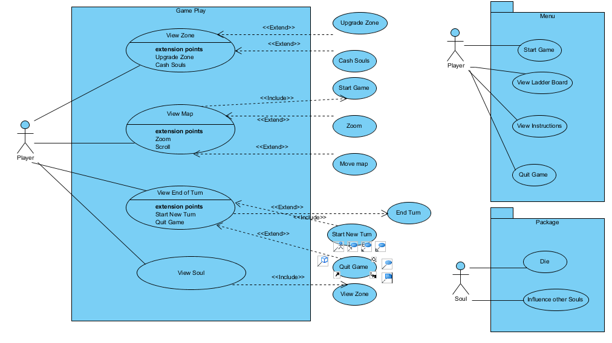

Figure 1.0

## Class Diagram

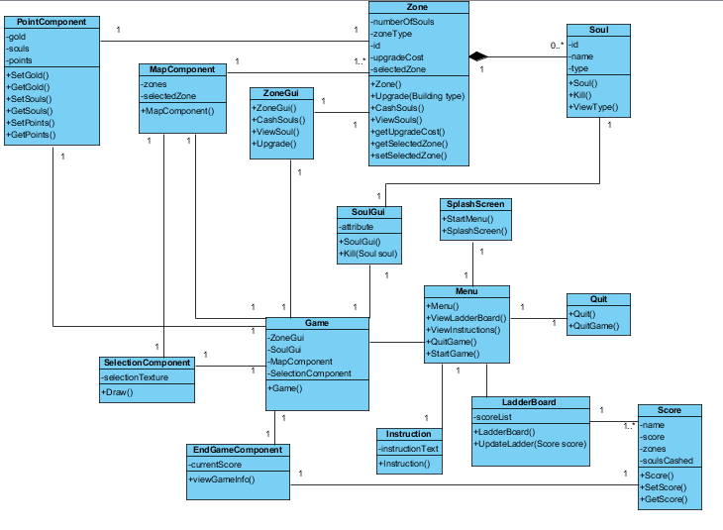

Figure 1.1

## Turn Component Story Class

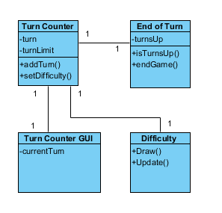

Figure 1.2

## View Highscores Story Class

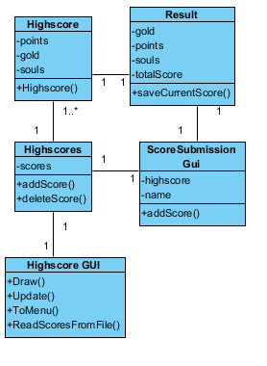

Figure 1.3